Information James to see what Claude AI thinks

Ply data:

Table 1. Material properties of a UD ply of the CFRP laminates [Ref. A].
Property |  | Value
Moduli ($GPa$) |  | $$E_{11}=115; E_{22}=E_{33}=8.2$$  $$G_{23}=3.6; G_{12}=G_{13}=3.6$$
Poisson`s ratio |  | $$ν_{23}=0.34; ν_{12}=ν_{13}=0.34$$
Strength, S, values (MPa) |  | $$S_{1t}=2282; S_{2t}=S_{3t}=54$$  $$S_{1c}=1067; S_{2c}=S_{3c}=200$$  $$S_{12}= S_{13}= S_{23}=99$$

Ref A. Liu H, Liu J, Hall ZE, Brooks RA, Crocker JW, Joesbury AM, Harper LT, Blackman BR, Kinloch AJ, Dear JP. Modelling the effects of patch-plug configuration on the impact performance of patch-repaired composite laminates. Composites Science and Technology. 2023; 233: 109917.

Lay up for QIT, DD30 and DD45 rectangular panels, each is 16 plies:

QIT: 45/45/-45/-45/0/0/90/90/90/90/0/0/-45/-45/45/45

DD30: 30/-60/-30/60/30/-60/-30/60/30/-60/-30/60/30/-60/-30/60

DD45: 45/-45/-45/45/45/-45/-45/45/45/-45/-45/45/45/-45/-45/45

The size of each rectangular panel is 150 mm x 100 mm and they are 4.6 mm thick. Each ply is 4.6 mm / 16 plies = 0.2875 mm thick, when consolidated into panel.

On the attached Excel spreadsheet, I have worked out D11, which I think is maximum stiffness, to out of plane loading.

This gives values of D11 of 360 kN mm, 345 kN mm and 290 kN mm for QIT, DD30 and DD30 panels.

Experimentally, the initial slope or stiffness for the load deflection behaviour, of the rectangular panel simply supported around its edge is similar for QIT, DD30 and DD45 (see Figure 1 below). In these experiments, the panels were 150 mm × 100 mm panels and of total thickness 4.6 mm in each case. The composite panels were secured to a steel picture frame using four rubber-tipped toggle clamps to prevent panel movement during impact testing. Three guide pins were used to position the panel at the centre of the impact region above a 125 mm × 75 mm window cut-out. So, the panel could be considered as simply supported of size 125 mm x 75 mm x 4.6 mm thick. The load–time response was recorded using a load cell mounted in the front section of the impactor at a sampling rate of 500 kHz. The impactor pushes down on the centre of panel and the load versus displacement, or deflection, at centre of rectangular panel is plotted in Figure 1.

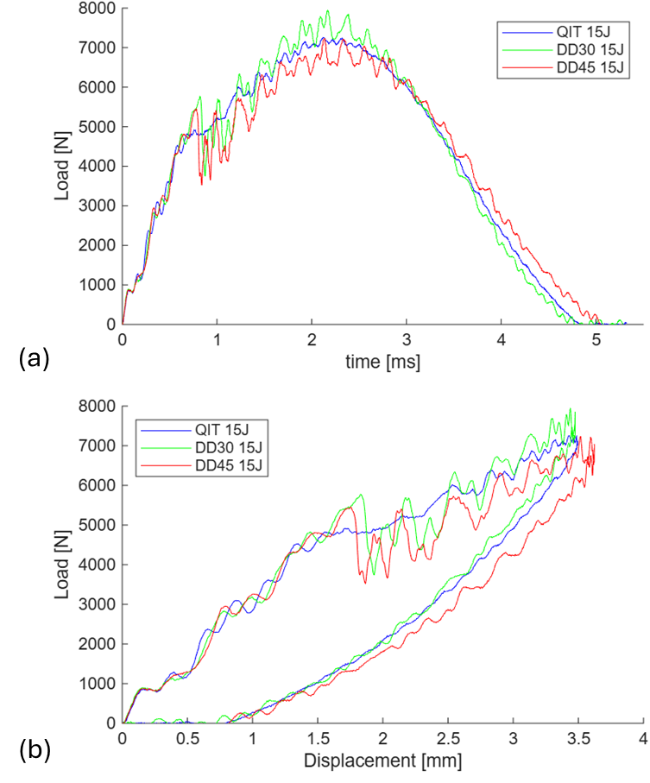

Figure 1: Load traces for QIT and Double-Double composite panels at 15 J: (a) Load versus time traces and (b) Load versus displacement traces.

The questions for Claude AI:

The experimental value of panel out of plane stiffness (central load / central out of plane deflection) for the QIT, DD30 and DD45 is approximately 3kN/mm, as observed in Figure 1 above.

The question is what the theoretical value for panel out of plane stiffness (central load / central out of plane deflection), based on the laminate layup and material properties and dimensions of laminate above?

In the Excel spreadsheet, are the values of D11 calculated, namely 360 kN mm, 345 kN mm and 290 kN mm for QIT, DD30 and DD45 panels, correct?

What is relationship between D11 and panel out of plane stiffness (central load / central out of plane deflection)?

Note: Alternatively, an FEA program could be written to predict the panel out of plane stiffness – Dr Yuzhe Ding and Prof. Haibao Liu may be able to help.

